4. State of the art personal protective equipment.
5. Pride and sense of belonging as well as providing a service to your community

Additionally
For those who are unable to become a emergency responder or just don’t feel that you would like to be a firefighter, EMT, fire police or scene support we have developed a social member category, This person is able to help our department in other areas, Fundraisers, secretarial, open houses, consulting and other various behind the scene assistance.

Apply TODAY
Jamesville Volunteer Fire
Department
6661 East Seneca Turnpike
Jamesville, NY, 13078
www.jamesvillefire.org
(315) 492-2872

Volunteer are
Needed

Are you up for the
Challenge?
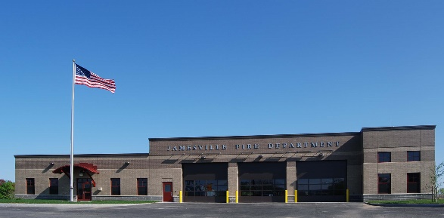
Will you heed the
Call?
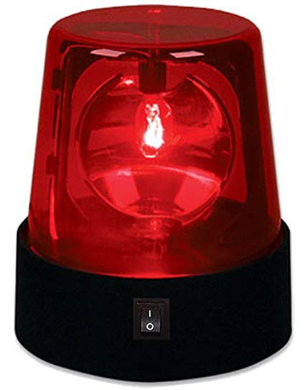
Be one of the few who
Can proudly say:
I Volunteer
What if no one answered the call?
A storm breaks out unexpectedly in our town. Lighting causes a house to catch fire. Cars crash in the blinding snow. A person fall, has a heart attack, or is injured by a power tool.
What if no one answered the call? That is something we as volunteers can prevent and do prevent. Though our numbers are declining, people still rise to the call. That is what volunteering is about. Helping others
Join us!
Why become a volunteer?
- Have you ever heard a siren or seen a fire engine and wondered what was happening?
- Have you ever witnesses or come upon a motor vehicle accident and wished you could help?
- Have you been there when someone was stricken with a sudden illness and you wanted to assist but you weren’t sure what to do?
- Are you looking for a group to belong to that is like and extended family that share a challenges?
- Are you looking for an awesome way to give back to you community?

Then Volunteering is for
You!
Volunteers are needed
Every day, in our community, volunteer emergency responder’s answer the calls of our families, friends, and neighbors who are in the need of assistance. From the heart attacks to car accidents, from house fires to technical rescue, volunteers respond to, protect and or assist their fellow citizen.

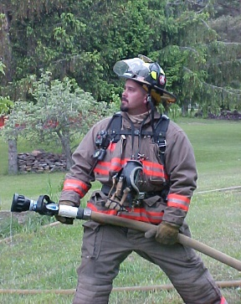
Volunteer emergency responders are made up of many different backgrounds. Including doctors, lawyers, teachers, students, electricians, plumbers and town workers to name a few. There is a need for all kinds of people in the volunteer service. Emergency responders are special people with many different reason to answer the call of duty. Some like challenges and the adrenaline rush, while other like to sharpen their emergency responder skills and techniques. Yet every one of them answers the call so that they can help someone in need

What can you do?

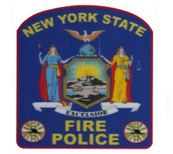
Become a NYS Certified Fire Police Officer
- Assist in the control of traffic at the scene of emergencies.
Firefighter 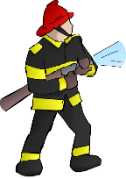
- Investigate, extinguish, search, stabilize vehicles, extricate evaluate, climb ladders, use jaws of life …
(EMT) 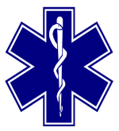
- Lean and provide direct medical care to patients stabilize and package them for transport to the hospital,

Scene Support

- Preform fire scene operations outside of structures, place, ladders, lighting and support interior firefighter as directed by command

These are some general expectations.
- Respond to a minimum percentage of emergency calls
- Attend a minimum number of drills each year.
- Attend department meetings.
- Train to stay healthy
- Participate in special details and other department functions.

Benefits!
- Free training for the task you will undertake.
- A New York State income tax credit of $200.00 for active volunteers.
- Service awards program for which funds are place in a pension for each year of credited service, once vested, this money is yours when you reach retirement age.

